Exclusion from Education in Malawi

Rapid Diagnostic Assessment

Global Context
According to UNESCO, more than 272 Million Children are out of school worldwide, with close to 30% of these children in Sub-Saharan Africa.(UNESCO 2024) Even where children are in school, many are not achieving the foundational learning levels; 9 in 10 students in Sub-Saharan Africa cannot read and understand a simple story. (“The State of Global Learning Poverty” 2022) Exclusion is not spread equally, and globally children who are orphaned, disabled, and whose parents are not educated are at a higher risk of dropping out of school.

With aid to education projected to fall by $3.2 Billion (24%) in 2026(UNICEF 2025), allocation of resources to those who most need them is of vital importance, to ensure that every child has the opportunity to have the skills and knowledge to prosper and contribute to their societies.

Education and Exclusion in Malawi
Malawi is a landlocked country in East Africa with a dense and rapidly growing population, 21.6 Million at 2024. Malawi’s formal education starts at 6, with 8 years of free primary, and 4 years of paid secondary education. (Ministry of Education, Science, and Technology 2019)

Malawi spends about 5.2% of GDP and 19.2% of government expenditure on education, which are within UNESCO Education 2030 Framework for Action (FFA) benchmarks.(UNESCO Institute for Statistics ( 2025).

The Multi-Indicator Cluster Survey (MICS) generates data on households and children on a variety of topics, such as health, education, and child safety, and in many contexts is the best source of data on children. The Integrated Household Survey (HIS) is one of the key sources of statistical information implemented by the Malawi Government.

Wealth as the Primary Predictor of Educational Exclusion

Group | % Out Of School  (Total) | % Out Of School  (Wealth Q1) | % Out Of School  (Wealth Q5)
Rural Boys | 3.7 | 6 | 1.6
Rural Girls | 3.4 | 5.5 | 2.1
Urban Boys | 1.9 | 1.5 | 1.4
Urban Girls | 1.1 | 0 | 1.2
Disabled | 4.4 | 5 | 3
Orphaned | 4.5 | 7.3 | 2.8
Household Head Completed Primary School | 1.7 | 3.1 | 1.4

Overall, 3.3% of children are out of school in Malawi, but with significant variations based on socio-economic status and other risk-factors. Analysis of the MICS foundational learning module shows that older children are more at risk of being out of school, with each additional year adding 12% likelihood of being out of school. Household wealth quintile is also highly predictive of a child being out of school, with children in the highest wealth quintile only 30% as likely to be out of school, as children growing up in the richest quintile of households. Disabled and orphaned children are both also at a significant heightened risk of being out of school. Sex and rurality do not have a statistically significant impact on the likelihood of being out of school. See Appendix 1 for odds ratios.

Gender and Rurality Significantly Impact Earning.
Overall, only 28.6% of children aged 6-13 can read at an expected level.

FIGURE 1:  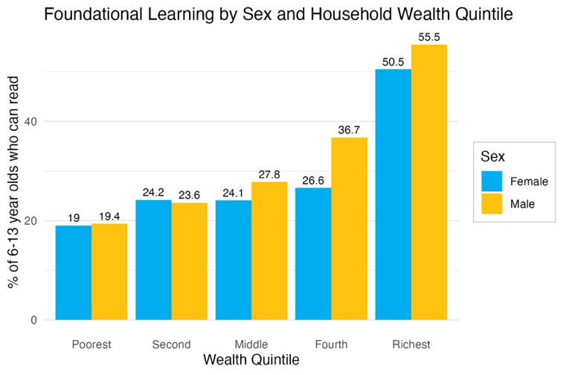 | 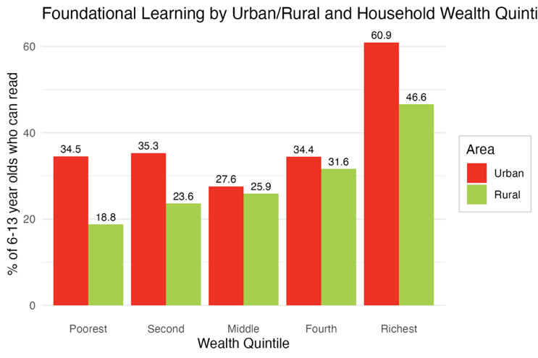

Wealth is also highly predictive of ability to read, though with no statistically significant difference between the poorest and second quintile. Disabled Children are less likely to be able to read. Unlike likelihood of being out-of-school, sex and rurality are statistically significant for foundational reading, with girls and urban children both more likely to be able to read than their male and rural counterparts. Figure 1 below shows that gender differences become more pronounced at higher wealth quintiles. See appendix 2 for regression results. See Appendix 2 for odds ratios.

Outcomes are worse in the Centre and the South.
There is substantial geographic differentiation in school attendance and foundational reading outcomes across districts in Malawi.

Whilst Lilongwe City has the highest percentage of children with foundational learning skills, the Lilongwe Rural district has the second lowest percentage of children with foundational learning skills.

Rank | Lowest Reading | Highest Reading | Most Out-of-School | Least Out-of-School
 | Mangochi | Lilongwe City | Dowa | Blantyre Rural
 | Lilongwe Rural | Mzuzu City | Lilongwe Rural | Mzuzu City
 | Dedza | Blantyre City | Salima | Chitipa

Both out-of-school rates and the percentage of children who cannot read are higher in the centre and south of the country.
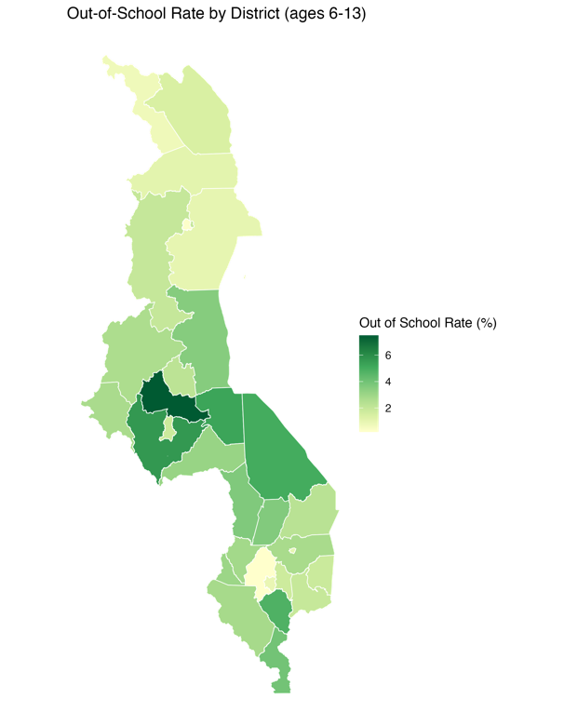 | 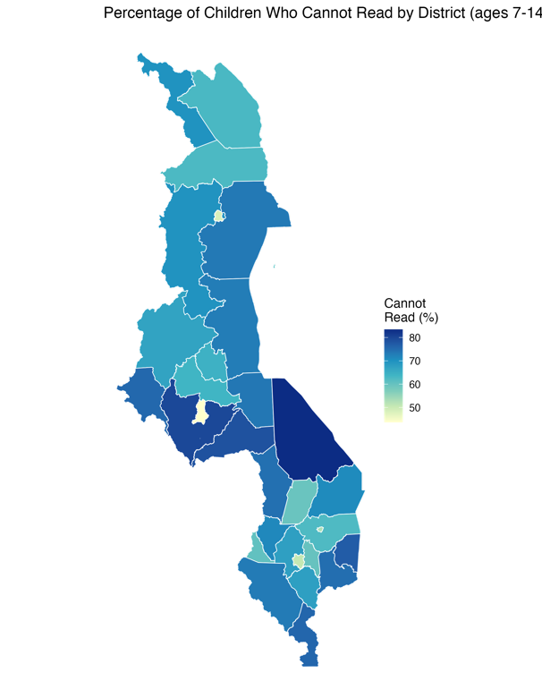

Policy Implications
Given a growing young population, and limited education aid, Malawi must prioritize support for children who face the greatest risk of exclusion. Three groups that would benefit from targeted support would be:
- Children in the poorest wealth quintile, who are three times as likely to be out of school as their wealthiest peers.
- Orphaned and disabled children - who experience exclusion rates of 4.5% and 4.4% respectively, compared to the national average of 3.3%
- Rural children and boys - who significantly lag in foundational reading skills despite similar school attendance rates

Research Proposal

Title: Understanding Learning Poverty and Warning Signs in Malawi Primary Schools

Motivation
Children in Malawi face very high learning poverty. Despite expanded enrolment in the last two decades. Many children finish primary school without gaining foundational reading or mathematics skills.

Existing data, including from Malawi’s Integrated Household Survey (HIS, last run 2019-2020) and UNICEF’s Multi-Indicator Cluster Survey (MICS, run 2019-2020) give useful information on foundational learning outcomes. However, MICS does not target school-level factors, such as teacher quality and classroom practice, which we know have an important impact on learning outcomes. This limits policymakers ability to design instruments that target and support at-risk children before they fall irreparably behind.

To support the Government of Malawi’s National Education Sector Investment Plan, and Education Partnership Compact, which focus on Foundational Learning and geographic disparities, this study will look at child, school, and household factors to understand the inputs that are needed to help Malawi’s children stay in school, and learning.

Research Objectives
To understand and predict education exclusion and learning poverty in Malawi,
Research Questions:
- Which children in Malawi are falling behind in foundational learning?
- Which school and household factors can help to identify at-risk children?

Conceptual Framework

Literature
Building on Mincer’s education production function (SOURCE), Hanushek proposes that education is the function of not just years of schooling, but also of other inputs, such as teacher quality, family environment, and community engagement.

Importantly, supply-side factors, such as teacher absenteeism, are more viable mechanisms for intervention than household wealth or parental education status.

This study will look at both factors that are useful identification mechanisms and factors that are useful intervention mechanisms.

Empirical Strategy

District Stratification
This research will employ a stratified cluster design, stratifying by high-, medium- and low- performing districts across 3 regions in order to capture regional variation, and to allow comparison between higher- and lower- performing areas. This design allows for district-level analysis in areas of interest, whilst weighting ensures national representativeness.

Sampling Strategy
Unlike MICS, which uses households as the sampling unit, this study uses schools as the primary sampling unit, which allows for collection of teacher- and school-level data and linkage to student performance. Across all districts, a target of 200 schools will be sampled to provide sufficient statistical power for analysis.

Children
Within each school, a sample of 25 children across standard 4 (where foundational learning should be established) and standard 8 (final year of primary school.) will receive the MICS foundational learning test.

Teachers
Teachers will answer:
- A survey of teacher perception of student learning
- A self-administered experience questionnaire quantifying years of experience, qualifications, attendance, and job satisfaction.
- A self-administered knowledge questionnaire testing basic knowledge of literacy, numeracy, and pedagogical practice.
- Enumerators will make unannounced school visits to verify teacher attendance.
- Given adequate resource, enumerators will do classroom observations in a subset of classrooms to review teaching practice.

Households
For 1/3 of children (to manage costs) a household visit will follow the learning test at school, where parental engagement and perception of child’s learning and socio-economic environment will be measured. For students not visited, proxies will be measured e.g. whether the child ate breakfast, whether they have books at home, how they got to school.

Analysis
Analysis will be conducted in 3 phases
- Descriptive Analysis – Phase 1 will thoroughly describe learning poverty in Malawi, providing weighted estimates of the proportion of children not meeting foundational reading and numeracy benchmarks, disaggregated by sex, district, urban/rural and socio-economic status. For priority districts, district reports will also be produced to support policy-making at the local level.
- Predictive Analysis – Multi-level regression, looking at children, and districts, will use household, and school/teacher factors to predict outcomes. Machine learning approaches (random forest) will complement regressions, and models will be cross-evaluated to ensure predictive accuracy.
- Tool Development – A tool will be produced using a minimum viable subset of indicators that are both predictive and readily observable. Thresholds will be established in consultation with local officials and parents, and validated with test data.
Data will be analysed in R with full documentation to ensure reproducibility by local officials.

Organisational Strategy

Survey Administration
Enumerators will be locally recruited and use Kobo, with surveys translated and back-translated to ensure accuracy. School visits will happen during term-time, with household visits happening at evenings and weekends, with standard visit protocols to be established.

Training and Quality Assurance
Enumerators will undergo a 5-day training covering interview techniques, software use, ethics, prevention of Sexual Abuse and Exploitation (PSEA,) and a pilot in a non-sample school. Only enumerators who pass an assessment will be used. School data will be GPS and time verified using Kobo, with supervisors doing daily check-ins with enumerators, and visiting a random subset of schools for verification

Ethics
The study will be reviewed by ethics boards in Malawi and by the institutional partner. Written consent will be given by principals, teachers, and parents, and caregivers will provide written consent for children, with children providing verbal consent. It will be made clear to participants that participation is voluntary and that they can withdraw at any time. Child protection protocols will be put in place.

Timeline
The study will be implemented over a 15 month span:
Months 1-3 | Ethical Approvals, Sampling Frame Construction
Month 3 | Enumerator Recruitment and Training
Month 4-6 | Sampling
Month 7-9 | Quantitative Data Analysis
Month 10-11 | Target tool development and validation
Month 12-13 | Report Writing
Month 14-15 | Dissemination, Policy Engagement

AI disclosure
For efficiency, and because I think it’s reflective of the environment in which research is now done, I used Claude Code to do much of the data processing in this report, and to create initial statistics and graphs, which I fully understand how to do manually and edited by hand to get desired stats, occasionally using Claude to support debugging. I asked Claude to suggest the file structure for GitHub and to do a quick initial scan for relevant literature. If this is contrary to the rules of the task, then it was a misunderstanding, and I am sorry.

All written work is my own.

References
Ministry of Education, Science, and Technology. 2019. Malawi Education Sector Analysis. Lilongwe,Malawi.
“The State of Global Learning Poverty: 2022 UpdateThe World Bank, UNESCO, UNICEF, USAID, FSDO, Bill and Melinda Gates Foundation, 2022, 77 p., Open Access.” 2022. Population and Development Review 48 (4): 1215–16. https://doi.org/10.1111/padr.12534.
UNESCO. 2024. Global Education Monitoring Report, 2024/5, Leadership in Education: Lead for Learning. GEM Report UNESCO. https://doi.org/10.54676/EFLH5184.
UNESCO Institute for Statistics (. 2025. “Government Expenditure on Education, Total.” Https://data.worldbank.org/indicator/SE.XPD.TOTL.GD.ZS?locations=MW, September.
UNICEF. 2025. Education Aid Cuts: A Broken Promise to Children. UNICEF/UNI545674/ELFATIH. UNICEF.

Appendices

Appendix 1 – Odds Ratios for Out of School Rate Logistic Regression
Variable | Odds Ratio | 95% CI | P-value
Age | 1.12 | 1.09 - 1.16 | *0
Sex - Female | 0.92 | 0.79 - 1.07 | 0.272
Rural | 1.02 | 0.75 - 1.4 | 0.906
Wealth Quintile 2 | 0.75 | 0.62 - 0.92 | *0.005
Wealth Quintile 3 | 0.51 | 0.41 - 0.63 | *0
Wealth Quintile 4 | 0.43 | 0.34 - 0.54 | *0
Wealth Quintile 5 | 0.3 | 0.22 - 0.41 | *0
Orphan | 1.41 | 1.15 - 1.71 | *0.001
Disabled | 1.58 | 1.2 - 2.05 | *0.001
Household Head Completed Primary School | 0.63 | 0.49 - 0.8 | *0

Appendix 2 – Odds Ratios for Foundational Reading Logistic Regression

Variable | Odds Ratio | 95% CI | P-value
Age | 1.48 | 1.45 - 1.51 | 0
Sex - Female | 1.35 | 1.23 - 1.48 | *0
Rural | 0.63 | 0.55 - 0.73 | *0
Wealth Quintile 2 | 1.16 | 0.99 - 1.37 | 0.07
Wealth Quintile 3 | 1.25 | 1.07- 1.46 | *0.006
Wealth Quintile 4 | 1.75 | 1.5 - 2.04 | *0
Wealth Quintile 5 | 3.33 | 2.83 - 3.93 | *0
Disabled | 0.86 | 0.74 - 0.99 | 0.039

